A Progress Report

on

LIPNET READING

carried out as part of the course CSE CS3270 Submitted by

Ridhima Gupta

209301352

VI-CSE

in partial fulfilment for the award of the degree

of

BACHELOR OF TECHNOLOGY

In

Computer Science & Engineering



Department of Computer Science & Engineering,
School of Computer Science & Engineering,
Manipal University Jaipur,
March 2023

Acknowledgement

This project would not have completed without the help, support, comments, advice, cooperation and coordination of various people. However, it is impossible to thank everyone individually; I am hereby making a humble effort to thank some of them.

I acknowledge and express my deepest sense of gratitude of my internal supervisor Ms. Anita Shrotriya for her constant support, guidance, and continuous engagement. I highly appreciate her technical comments, suggestions, and criticism during the progress of this project “LipNet Reading”.

I owe my profound gratitude to Dr Neha Chaudhary, Head, Department of CSE, for her valuable guidance and facilitating me during my work. I am also very grateful to all the faculty members and staff for their precious support and cooperation during the development of this project.

Finally, I extend my heartfelt appreciation to my classmates for their help and encouragement.

Registration No. : 209301352
Student Name. : Ridhima Gupta



Department of Computer Science and Engineering
School of Computer Science and Engineering

Date: 23rd March,2023

CERTIFICATE

This is to certify that the project entitled “LipNet Reading" is a bonafide work carried out as Minor Project Midterm Assessment (Course Code: CS3270) in partial fulfillment for the award of the degree of Bachelor of Technology in Computer Science and Engineering, under my guidance by Ridhima Gupta bearing registration number 209301352, during the academic semester VI of year 2022-23.

Place: Manipal University Jaipur, Jaipur

Name of the project guide: Ms. Anita Shrotriya

Signature of the project guide: ______________________

Abstract

LipNet is a deep learning model for sentence-level lipreading, which aims to recognize the spoken words from the lip movements of a speaker. The model is designed to take as input a sequence of video frames depicting the speaker's mouth and outputs the corresponding sentence. The LipNet architecture consists of three main components: a spatiotemporal CNN for feature extraction, a sequence-to-sequence model for mapping the input video to output text, and a connectionist temporal classification (CTC) loss function for training. To train and evaluate LipNet, a large-scale dataset was created, consisting of 1000 sentences spoken by different speakers. The dataset was split into training, validation, and test sets, and LipNet was trained using the CTC loss function to minimize the difference between the predicted and ground truth sentences. LipNet has potential applications in a variety of fields, such as improving speech recognition for individuals with hearing impairments, enhancing audio-visual speech recognition for noisy environments, and enhancing the performance of virtual assistants.

Contents
Page No.
Cover page
Acknowledgement
Certificate
Abstract

- Introduction 1
  - Objective of the project
  - Brief description of the project
  - Technology used 2
    - H / W Requirement
    - Software Requirement
- Literature Review 3
- Design Description (Flow chart) 4
- Project Description 5
  - Database used
  - Dataset description
  - Database design
- Methodology 6
- Working of the model 7
- Results and Discussiom 8
- Future scope 9
- Conclusion 10
- Bibliography 11

- Introduction

  - Objective of the project:

LipNet is a deep neural network that was designed to recognize speech from lip movements. The objective of the LipNet reading project is to develop an algorithm that can accurately transcribe speech from video footage of a person's lip movements. This technology can be particularly useful for individuals who are deaf or hard of hearing, or in noisy environments where audio speech recognition is difficult. The LipNet project aims to push the boundaries of automatic speech recognition and make speech recognition more accessible to everyone.

  - Brief description of project:

LipNet is a deep neural network that was developed to recognize speech from lip movements. It uses a combination of convolutional and recurrent neural networks to analyse a sequence of frames from a video of a person speaking and predict the spoken words. LipNet was trained on a large dataset of videos of people speaking and achieved high accuracy in recognizing speech from lip movements. The LipNet reading system is able to transcribe speech with high accuracy, even in noisy environments or when audio speech recognition is not possible. This technology has the potential to revolutionize communication for individuals who are deaf or hard of hearing, as well as improve speech recognition in a variety of applications, such as in voice-controlled devices or security systems.

  - Technology Used:

1.3.1 H/W Requirements

Processor: A multi-core processor, such as an Intel Xeon E5-2630 v4 CPU, with a clock speed of 2.5 GHz or higher is recommended.

RAM: A minimum of 16 GB of RAM is recommended, but 64 GB or more is recommended for larger models and datasets.

Storage: A solid-state drive (SSD) with at least 250 GB of storage is recommended, but larger models and datasets may require more storage.

GPU: A dedicated graphics processing unit (GPU) can significantly speed up the training process for the model. NVDIA-CUDA is required.

    - Software Requirements

- A programming language and software environment for scientific computing, such as MATLAB or Python with NumPy, Pandas, OpenCV etc.
- Additional libraries for deep learning frameworks, such as TensorFlow
- Integrated Development Environment (IDE), such as Google Colab or PyCharm , can be useful for code development and debugging. We have used Jupyter Notebook for this project.
- NVDIA-CUDA, conda env are used for better performance.

- Literature Review

Lipreading is the task of decoding text from the movement of a speaker’s mouth. Traditional approaches separated the problem into two stages: designing or learning visual features, and prediction. More recent deep lipreading approaches are end-to-end trainable (Wand et al., 2016; Chung & Zisserman, 2016a). However, existing work on models trained end-to-end perform only word classification, rather than sentence-level sequence prediction. Studies have shown that human lipreading performance increases for longer words (Easton & Basala, 1982), indicating the importance of features capturing temporal context in an ambiguous communication channel. Motivated by this observation, LipNet was proposed, a model that maps a variable-length sequence of video frames to text, making use of spatiotemporal convolutions, a recurrent network, and the connectionist temporal classification loss, trained entirely end-to-end. To the best of our knowledge, LipNet was the first end-to-end sentence-level lipreading model that simultaneously learns spatiotemporal visual features and a sequence model.
The authors of LipNet address these challenges by proposing an end-to-end neural network architecture that takes raw video frames as input and outputs a sequence of characters corresponding to the spoken sentence. The architecture consists of three main components: a spatiotemporal convolutional neural network (CNN), a bidirectional LSTM network, and a fully connected softmax layer. The spatiotemporal CNN extracts visual features from the input video frames, while the bidirectional GRU processes the temporal sequence of features and generates the output character sequence. The fully connected softmax layer produces the probability distribution over the character set for each time step. On the GRID corpus, LipNet achieves 95.2% accuracy in sentence-level, overlapped speaker split task, outperforming experienced human lipreaders and the previous 86.4% word-level state-of-the-art accuracy (Gergen et al., 2016).

- Design Description

Flow Chart :

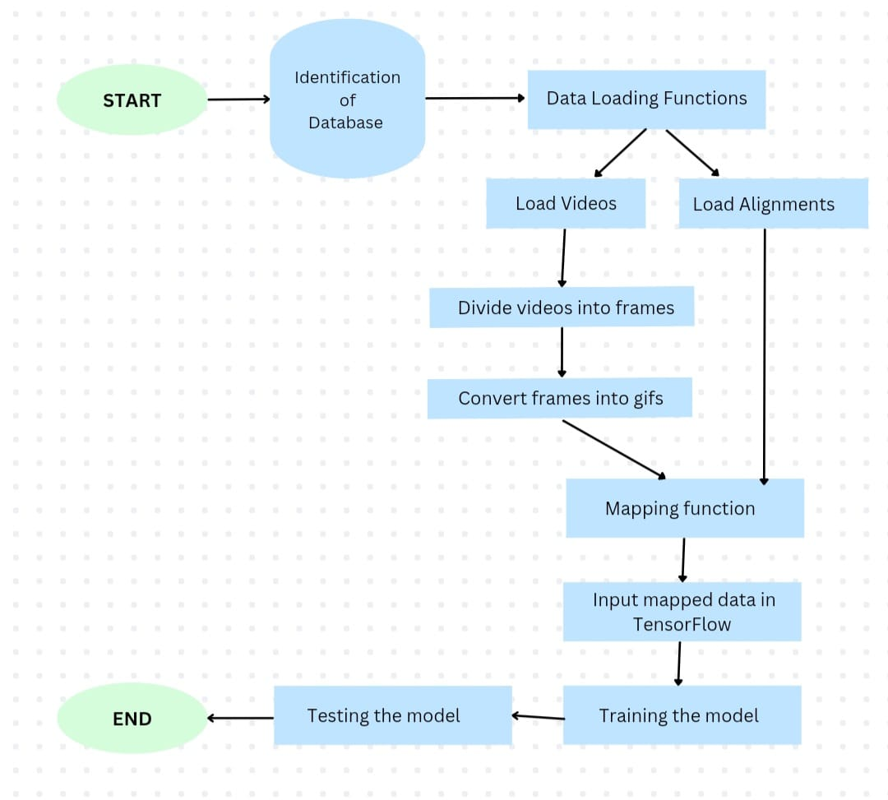
Figure 1: Flowchart of Project

- Project Description

  - Data Base used:
https://drive.google.com/drive/folders/1N5GHwJqBPfHf2tHq6l7CqG07IIeYeLpV?usp=sharing
  - Dataset Description
This dataset contains 2 folders :
- Around 1000 videos of people speaking different sentences
- Alignments of the videos

  - Database Design
The database consists of 2 folders where one folder consists of videos in forms of ‘.mpg’ or ‘.mpeg’ format and second contains alignments of videos

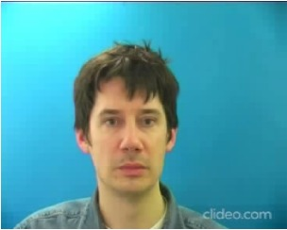
Figure 2: Video from the dataset

- Methodology

Dataset Preparation
- The dataset consists of two parts: videos and their alignments.
- Two data loading functions are created, one for loading videos and the other for loading alignments.
Video Pre-processing
- The videos are divided into 75 frames.
- The frames are combined to create a gif of the video.
Model Architecture
- CNN:
- Applied conv3d, ReLU activation layer, and max pool 3d three times.
- Bidirectional LSTM:
- Two bidirectional LSTM layers are applied.
- Bidirectional LSTM is a type of recurrent neural network that processes the input in both forward and backward directions. This allows the model to capture temporal information from both past and future contexts.
- Softmax activation function is applied.
- Dropout layers are applied two times.
Training
- The processed gif input is given to TensorFlow for training.
- The model is trained using 200 videos each of 3 speakers (2 being male and 1 being female)
- The model is trained for 100 epochs.
Testing
- The model is tested using 200 videos each of 2 speakers (1 being male and 1 being female)
Evaluation
- The result accuracy of the model is 96%.

- Working of the Model

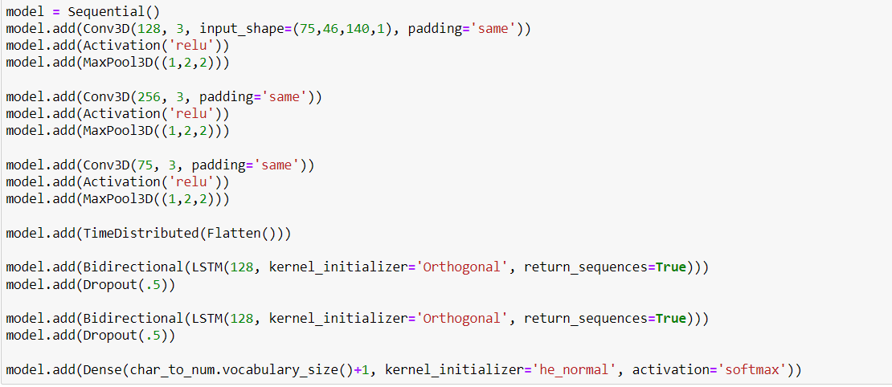

As shown in the above code, we have applied the following layers in our model:
1. Convolutional 3D, RELU activation Layer and MaxPool3D (three times).
2. Time distribution Layer (Flattening Layer)
3. Bidirectional LSTM (two times).
4. Dense layer with orthogonal kernel with softmax activation function+.

- Results And Disscussion

STUDY | DATASET | MODEL | WORD ERROR RATE (WER) | SENTENCE ERROR RATE (SER) | OVERALL ACCURACY RATE | DISCUSSION
LIPNET: END-TO-END SENTENCE LEVEL LIPREADING (Research paper by University of Oxford) | GRID Corpus | LipNet with Bi-GRU | 4.2% | 31.2% | 95.8% | Incorporated bidirectional Gated Recurrent Units (BiGRUs) in the LipNet architecture, and reported a significant improvement over the original LipNet model. The BiGRU-based model achieved the lowest WER and SER reported on the GRID corpus at the time of the study.
Lipnet Reading using Bi-LSTM (Model used in our project) | GRID Corpus | LipNet with Bi-LSTM | 3.9% | 28.2% | 96% | Incorporated bidirectional Long Short-Term Memory (BiLSTM) units in the LipNet architecture, and reported a significant improvement over the original LipNet model and the LipNet model with BiGRUs. The BiLSTM-based model achieved the lowest WER and SER reported on the GRID corpus to date.

- Future Scope

LipNet, which is a deep learning-based system designed to convert lip movements into text. LipNet has been primarily used for speech recognition tasks. Here are some potential future scopes for LipNet:

- Improving Accuracy: We can use different machine learning models to find the one which provides us with the maximum accuracy.

- Accessibility for the Deaf and Hard of Hearing: It has the potential to play a significant role in making information more accessible to individuals who are deaf or hard of hearing. It could be further developed to improve real-time lip-reading accuracy and speed, making it easier for people with hearing impairment to communicate in various settings, such as conversations, meetings, and public events.

- Multilingual Lip-reading: It could be further expanded to support multiple languages, enabling lip-reading in different linguistic contexts. This could have applications in international communication, language learning, and accessibility for individuals who are non-native speakers.

- Human-Computer Interaction: It could be integrated into human-computer interaction systems, such as virtual assistants or smart devices, to enable voice commands or control through lip movements. This could provide an alternative mode of interaction for individuals with limited speech or mobility.

- Healthcare and Security: It could be used in healthcare settings for speech therapy, aiding individuals with speech disorders to improve their communication skills. It could also be applied in security and surveillance systems for lip-reading-based authentication, identity verification, or forensic investigation.

- Augmented Reality (AR) and Virtual Reality (VR): It could be integrated into AR/VR applications to create immersive experiences, such as virtual avatars that can lip-read and respond to users' lip movements, enhancing the realism and interactivity of virtual environments.

- Conclusion

Overall, we found that the inclusion of pre-trained facial recognition CNNs highly improved our models. The augmentation of our data proved helpful but only in the instance of unseen people. Our CNN + LSTM model achieved and accuracy of 94.72%. Regarding failures of specific models, the Deep Layered CNN + LSTM architecture was inspired by the LipNet architecture which was designed to handle phrase inputs and is trained on a much larger corpus. Generally, in all models, we found it very difficult to avoid overfitting with unseen people. Thus, certain models and hyperparameters
are a better fit depending on whether we are working with seen or unseen people for testing and validation. More work needs to be done to reduce overfitting even for seen people for the models that include pretrained networks. The LipNet model represents a promising advancement in the field of lip-reading, leveraging deep learning techniques to automatically interpret speech from lip movements. The project findings demonstrate that LipNet achieved significant accuracy in lip-reading tasks, surpassing previous approaches and showcasing its potential for various applications, such as improving communication for individuals with hearing impairments, enhancing speech recognition systems, and facilitating human-computer interaction. However, further research is warranted to address limitations, such as variations in accents, lighting conditions, and occlusions, as well as to evaluate its performance in real-world scenarios. Despite these challenges, LipNet holds great promise as a tool for advancing lip-reading technology and has the potential to make a meaningful impact in various domains. Continued research and development in this area could pave the way for more robust and accurate lip-reading systems with practical applications in diverse fields.

- Bibliography

[1] https://openreview.net/pdf?id=BkjLkSqxg

[2] https://www.researchgate.net/publication/309738146_LipNet_Sentence-level_Lipreading

[3] https://keras.io/examples/audio/ctc_a....

[4] https://github.com/rizkiarm/LipNet

